**Twitter Data Sentiment Analysis**

**Set up details (Windows):**

1. The first thing you need to do is to install the setuptools module/package in python, for that first you need to navigate to the following link - <https://pypi.python.org/pypi/setuptools#setuptools> and download the [setuptools-5.3.zip](https://pypi.python.org/packages/source/s/setuptools/setuptools-5.3.zip#md5=1464c0da4425b0846ae842d52e5eb1dd) ([md5](https://pypi.python.org/pypi?:action=show_md5&digest=1464c0da4425b0846ae842d52e5eb1dd)) package into your project directory, install a tool like WinRaR or 7-Zip to unzip the module. After this step all the files will be present in a directory in your current working directory.
2. The second step is how you add the module to python’s standard library of all the packages and modules, well that’s quite easy too, open the command line shell and navigate to the directory where the setuptools module’s files were unzipped and execute the following command “**python setup.py install**” and boom it installs all the packages that are necessary for the upcoming “oauth2” installation. Here is a snapshot of how it needs to be done.

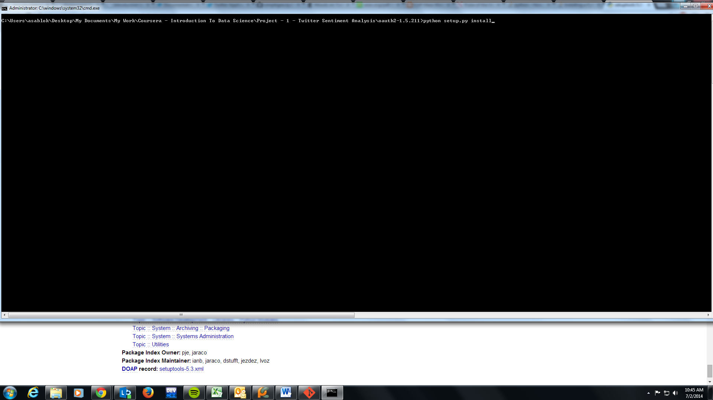

1. The third step in the setup is the installation of “oauth2” module of python, for that first visit the following link - <https://pypi.python.org/pypi/oauth2/> and download the tar.gz file corresponding to the module in the same directory in which you installed the setuptools.zip file and unzip it into a folder in the same directory. Now follow the same procedure to open the command line shell and navigate to the directory where you have oauth2 unzipped and execute the same command “**python setup.py install**” and you will see all the necessary packages getting installed in a flash.

**The next question is how I can get access to the live 1% stream of Twitter data:**

1. To gain access to live twitter feed you first need to make a twitter account. For this I made a separate Gmail account with the username – ankitsablokcoursera and password – ankitsablokcoursera123 and using this email account I also created a twitter account with the following credentials, username - Coursera1, password - ankitsablokcoursera123. And hooray I have my new twitter account as well.
2. After performing the above mentioned steps visit the following website - [**https://dev.twitter.com/apps**](https://dev.twitter.com/apps) and login with your twitter credentials, after you do that successfully you will be taken to the following page - <https://apps.twitter.com/> and it looks something like this.

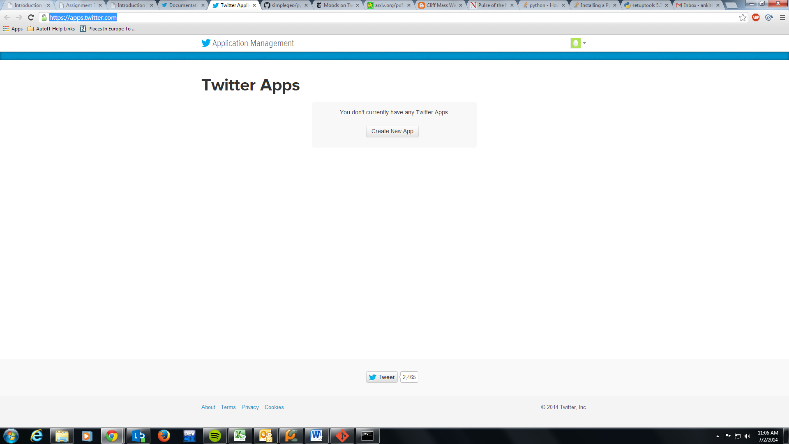

1. Click on the “**Create New App**” button and fill out the form that appears on the next screen, we fill out the details as shown in the figure below

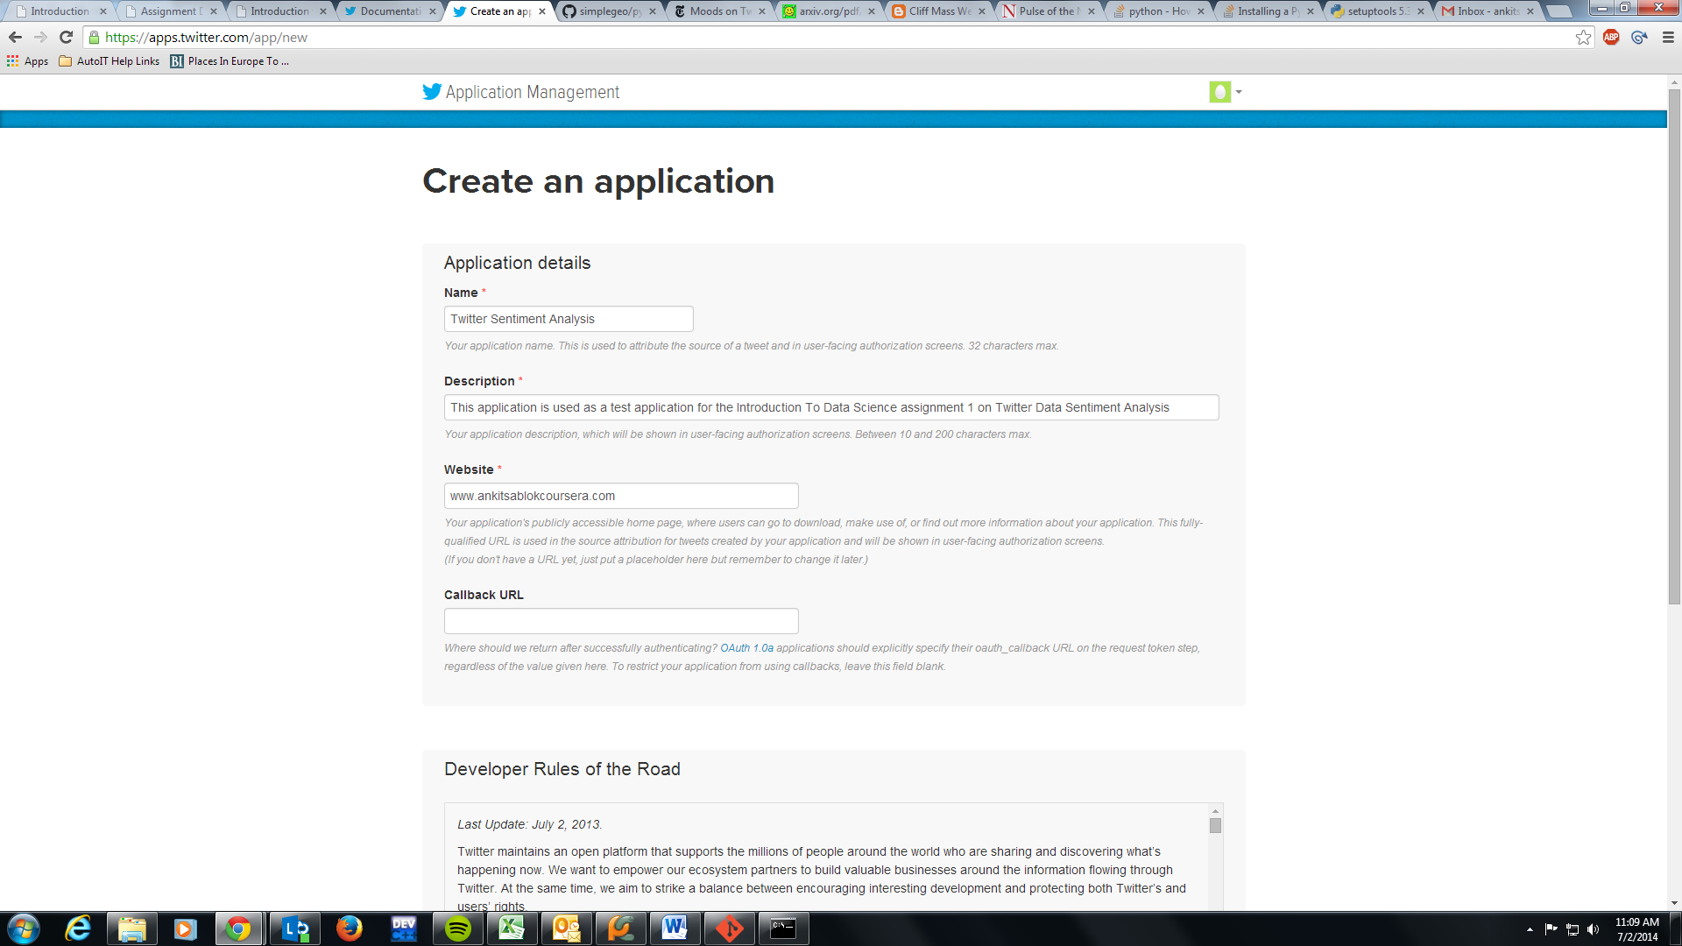

One particular thing that you need to be cautious of is the URL field in the form, one solution could be to just make a blog using google blogger and put that URL inside the field or you can put the URL of your valid website if you have one in the field for other solutions you can refer this discussion - <https://dev.twitter.com/discussions/3438> , after everything is validated you see a page like this

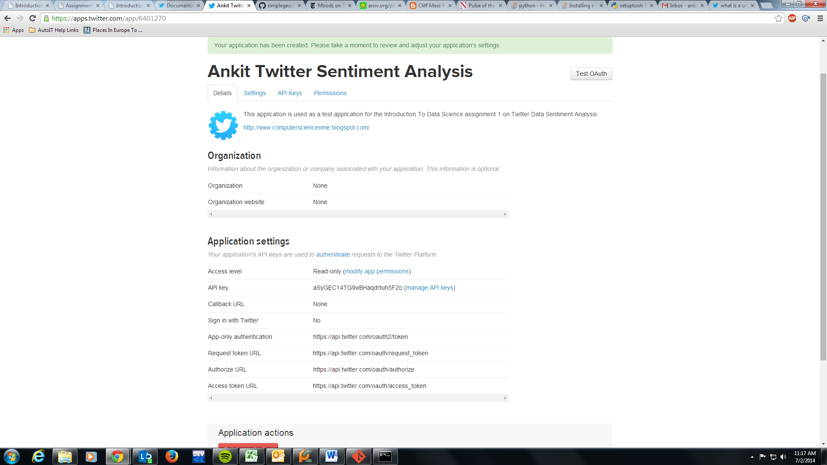

1. On the above page click on the “API Keys” tab and scroll down the page to click on “Your Access Token” button and you will see that in like a minute or so the access token will be generated for the application, here is the screen that shows all the details along with my access token.

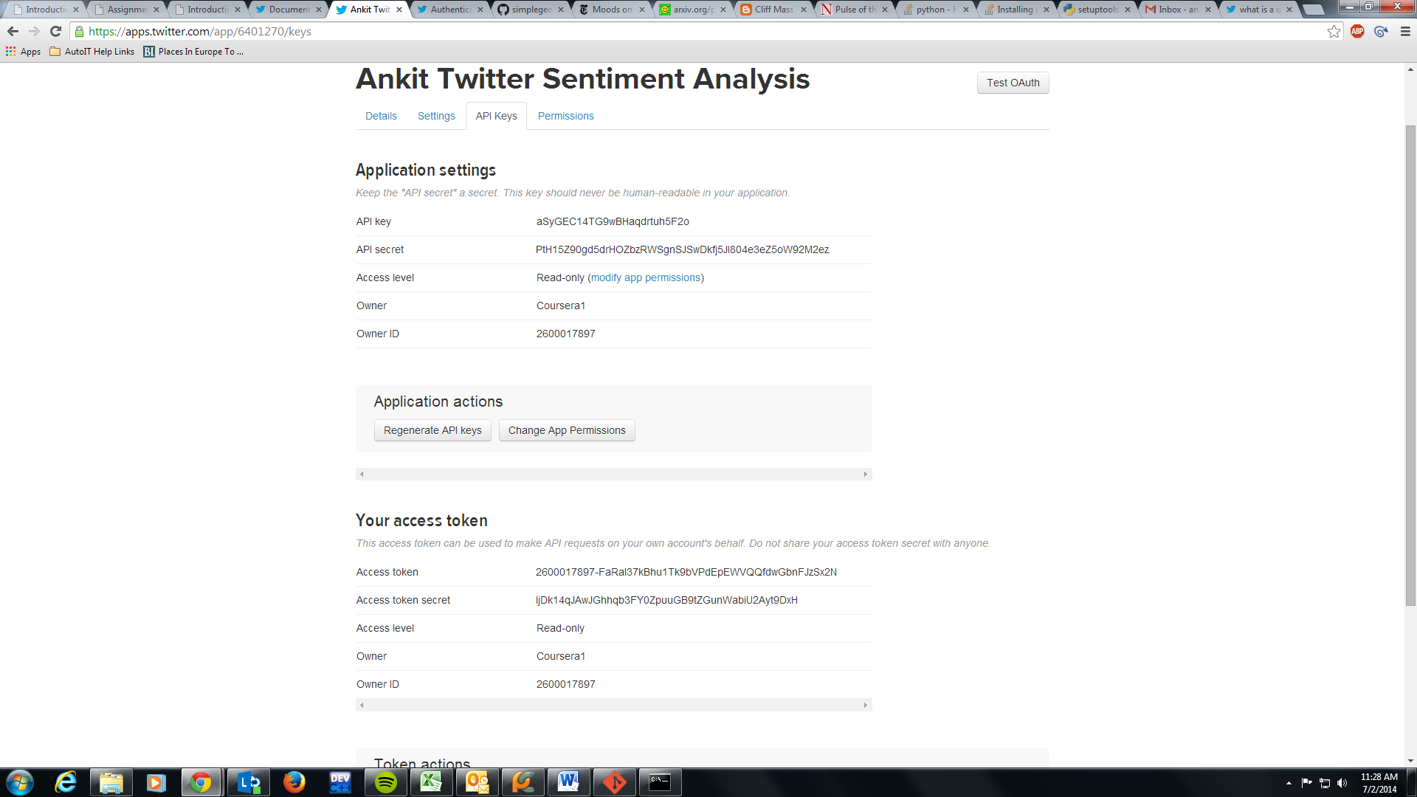

1. After doing all the configuration fill out the following details in the “twitterstream.py” file, your API key, your API secret key, your Access Token Key and your Access Token Secret in the file and now it should look something like this : <http://ideone.com/a4X6b0>
2. After making all the modifications in the file, just go on to the terminal and execute the following command “**python twitterstream.py > output.txt**” which will redirect the latest 1% of the data from the tweets into the output.txt file and here is how the file looks like after its done loading the data into the file.

